ENGLISH TEST
1.LISTEN AND CIRCLE

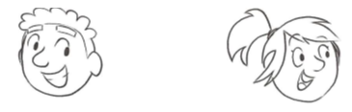

120
14
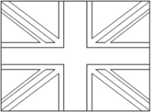

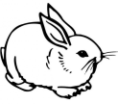
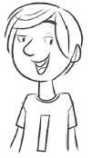
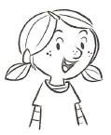

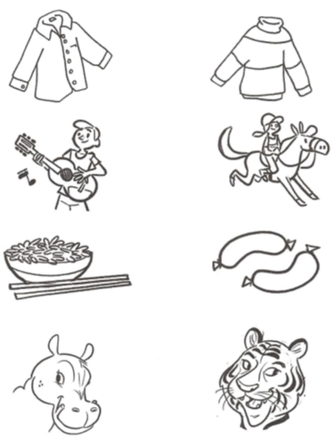

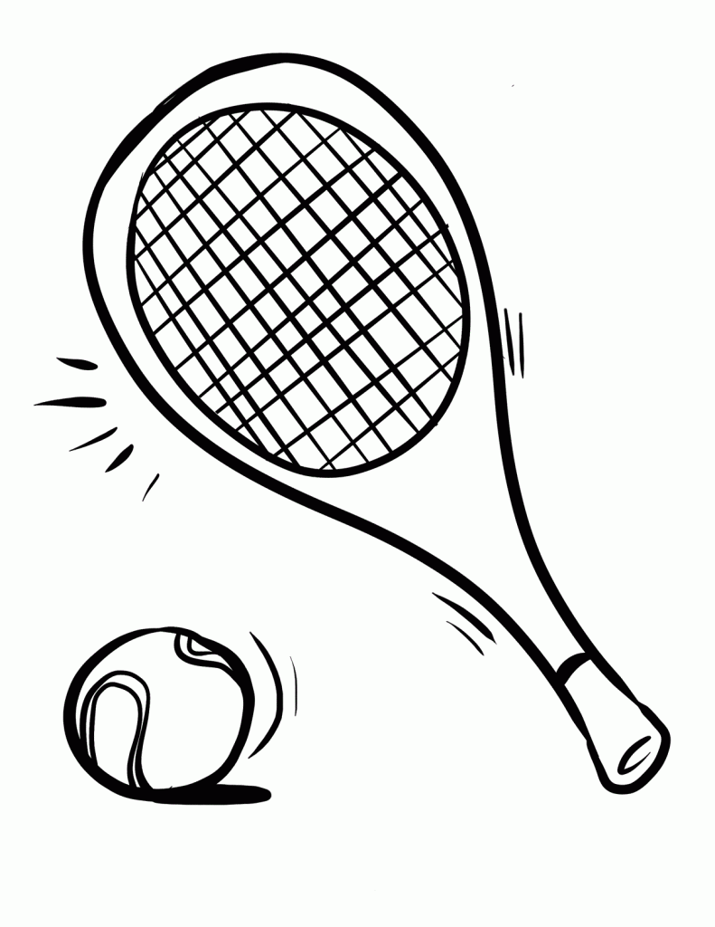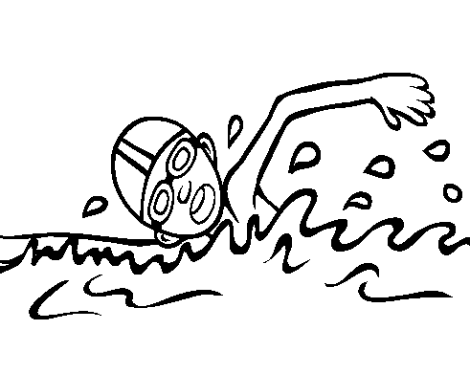
RABBIT - IS – LIKE – BROTHER – EIGHT FROM – CAN – SWIM – CHEESE
T-SHIRT - SPORT – TROUSERS
RABBIT - IS – LIKE – BROTHER – EIGHT FROM – CAN – SWIM – CHEESE
T-SHIRT - SPORT – TROUSERS

Name…………………………… Class……..
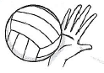2. LOOK AND COMPLETE
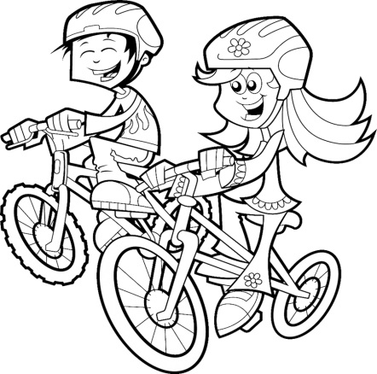
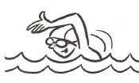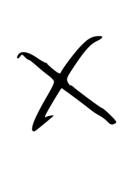
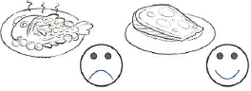

This……….. Amanda.
She’s ……..……..years old.
She’s …….…….Barcelona, in Spain.
She’s got a……………….…….., his name is
Alvaro.
She’s wearing a white………………….
and black …………………………..
She …………… ride a bike but she can’t
……………….
Her favourite ………………is volleyball.
She likes ……………….. but she doesn’t ………………. fish.
Her favourit

VERIFICA D’ISTITUTO DI FINE QUADRIMESTRE
CLASSE TERZA
READ AND CIRCLE YES or NO:
Read and circle Yes or No
My name is Susan. I am a girl.
I’m 7 years old.
My favourite colour is pink.
I’ve got a teddy bear. It is red and small. My doll is yellow and big.
I’ve got a pet .
It is a dog. My dog is small and brown.
I like strawberries.
I am happy.

NAME CLASS DATE

1) This is Susan | YES | NO
2) She is a boy | YES | NO
3) She is nine years old | YES | NO
4) Her favourite  colour is yellow | YES | NO
5) The teddy bear is red | YES | NO
6) The teddy bear is big | YES | NO
7) The doll is yellow | YES | NO
8) The dog is small and brown | YES | NO
9) She likes cherries | YES | NO
10) She is sad | YES | NO

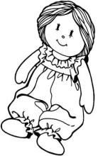

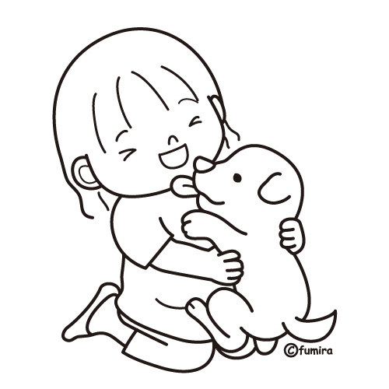

SCRIPT DELL’ASCOLTO
- Hello, I’m John
- I’m fourteen years old
- I’m from Great Britain
- I’ve got a little brother
- I’m wearing a new jumper
- I can play the guitar very well
- My favourite food is rice
- I like the zoo and I like hippos very much.
- In the afternoon I play tennis.
PROVA DI LETTURA (V- F)

