NOME ______________________ CLASSE _____ DATA _____________
VERIFICA DI ISTITUTO DI FINE QUADRIMESTRE
CLASSE QUINTA
- Read and complete the text. Use the words in the box.
starts - goes – works - likes - favourite - cooks - doesn’t -
wears – has - goes - straight
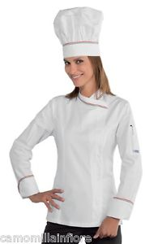

Grace is a cook : she ___________ her job very much.
She ______________ in a restaurant: she _____________ a big white hat and a white uniform. She ____________ delicious dishes!
She’s got brown eyes and ________ hair.
Grace ____________ working at 9 o’ clock in the morning and she _____________ back home at 3 o’clock in the afternoon.
She ________________ work in the evening.
At home Grace watches TV: her ______________ programme is
“Bake Off UK” . She __________ got a cat, Zoe, and she loves playing with her.
She _____________ to bed at midnight.

