Verifica di Storia 5^ sez. A / B Anno scol. 2017/18 Nome_____________________

1) Colora secondo le indicazioni la carta geografica

ARANCIONE Civiltà cretese

VIOLA Civiltà micenea

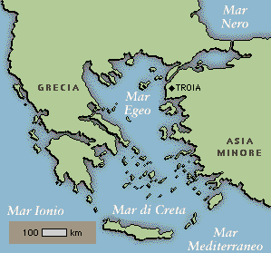

2) Dov’è sorta la Civiltà cretese? ___________________________________Quali caratteristiche fisiche aveva il territorio?___________________________________________________________

______________________________________________________________________________________________________________________

3) Dov’è sorta la Civiltà micenea?____________________________________ Quali caratteristiche fisiche aveva il territorio?___________________________________________________________
________________________________________________________________________________

4) Collega con una fraccia gli avvenimenti indicati sulla linea del tempo
INIZIO TRAMONTO FINE INIZIO
CIVILTA’ CIVILTA’ CIVILTA’ CIVILTA’
MICENEA CRETESE MICENEA CRETESE

5) Inserisci le informazioni nella tabella

 | CIVILTA’ CRETESE O ………………… | CIVILTA’ MICENEA O ………………….
ORGANIZZAZIONE  POLITICA | ___________________________________  ____________________________________  ____________________________________  ____________________________________ | ____________________________________  _____________________________________  ____________________________________  _____________________________________
ATTIVITA’ | _______________________________________  _______________________________________  _____________________________________  ____________________________________ | _____________________________________  _______________________________________  _______________________________________  ______________________________________
RELIGIONE | ______________________________________  _______________________________________ | _______________________________________  _______________________________________

6) Scrivi una leggenda che conosci della Civiltà cretese e una della Civiltà micenea

________________________________________________________________________________________________________________________________________________________________________________________________________________________________________________________________________________________________________________________________________________________________________________________________________________________________________________________________________________________________________________________________________________________________________________________________________________________________________________________________________________________________________________________________________________________________________________________________________________________

7) Osserva le fonti e scrivi di che tipo sono e a quale Civiltà appartengono
____________________________________________________________________________________________________________________ _______________________________________________________________________________________________________________________________________________________________________________________________________________________________________________________________________________________________________________________________________________________________________________________________________________________________________________________________________________________________________________

 

